BOROUGH GREEN MEDICAL PRACTICE
VASECTOMY INFORMATION PACK

IS VASECTOMY THE RIGHT CHOICE FOR YOU?
Our service is run by Dr Sudeb Mandal who is a GMC registered, full time NHS GP at the surgery and a member of the Association of Surgeons in Primary Care (ASPC). From time to time this procedure may be carried out by other GP’s within the Practice under Dr Mandal’s supervision. We use the no-scalpel cautery technique, which is recognised to be the technique that demonstrates best wound healing with the least amount of reported complications. We appreciate that you may be anxious about this procedure, however, we are confident that with the help of our nurse, we will be able to put you at ease and make the whole experience far easier than you expect.
Unfortunately we are unable to offer this service to our own patients registered at Borough Green Medical Practice.
It is very important that you read and understand this leaflet prior to your vasectomy appointment to enable us to be certain that you are in a position to give valid and informed consent. You will, of course, be able to ask any questions on the day of the procedure. It sometimes helps to make a note of anything you wish to ask to remind yourself on the day. We have left space at the end of the leaflet for this purpose.
What is a vasectomy?
Vasectomy is a surgical procedure which seals the sperm carrying tubes, preventing sperm getting into the fluid you ejaculate. The quantity and appearance of the fluid is not affected.
Who chooses vasectomy?
Anyone who feels that his family is complete or who is certain he will never want to have children. We will consider anyone, regardless of whether you are married, or whether you are already a dad.
We will counsel you on the day of your vasectomy so that we can answer any of your questions and ensure that you are happy with your decision. Your partner is very welcome to be present for this.
If you are under 30 we will recommend that you have extra counselling before you make a final decision. Whatever your age, you should consider vasectomy to be a permanent step and you should not undergo the procedure if you have any doubts. Vasectomy is not the answer if you are experiencing sexual problems or difficulties in your relationship.
How effective is vasectomy?
Vasectomy is highly effective and has a lower failure rate than any other method of contraception. However, there is a small chance of both early and late failure of the operation.
Early failure: Sometimes the sperm-carrying tubes (vas deferens) re-connect very quickly. This usually happens immediately after the procedure and we detect a large number of sperm in your semen test which you send by post 18 weeks after the operation. If this happens you cannot rely on your vasectomy and we will arrange some further semen tests. Some men have a larger store of sperm and take longer to clear. If the semen still shows a significant number of active sperm we will offer to repeat the procedure. The chance of this happening is approximately 1% (that is one in every hundred men having a vasectomy.
Late failure: In very unusual circumstances the sperm-carrying tubes reconnect some years later. You will have no way of knowing that this has happened. The chance of this occurring is estimated as 1 in 2000. This figure is almost certainly exaggerated and needs to be compared with the failure rates of the other available long-term contraception options when deciding on your vasectomy:
Vasectomy: failure rate 1 in 2000
Female sterilisation: failure rate 1 in 300
Mirena coil (IUS): failure rate 1 in 500
Combined oral contraceptive pill: failure rate 1 in 200
Condoms: failure rate 1 in 50

Preparing for the appointment
We are located in Borough Green and we have a large car park. You should bring your partner if possible and arrange for someone to take you home. If you have changed your mind about the procedure, or if on the day you are running late, please let us know so that the appointment can be used efficiently.

You can eat and drink normally. Please have a shower prior to the procedure. There is no need to shave your scrotum. Please come to the appointment wearing tight underpants/swimming trunks as this gives more support and enables the dressing pad to stay in position after the procedure.

Booking your appointment/what is the cost?
To book your appointment or if you have any queries please contact our Vasectomy Administrator, Lorna (Wednesdays and Thursdays 9.30 – 16.00) on 01732 881282 or by email – boroughgreen.vasectomyclinic@nhs.net

For private patients the cost is £495.00 which includes a non-refundable deposit of £95.00 taken at the time of booking. We require 10 days notice if you have to change your appointment for any reason. Please bring cash or debit card on the day of your appointment.

Where will it take place?
Your vasectomy will take place in our modern, fully equipped, minor surgery suite.

Letting us know of significant Medical History
If you have had surgery to the scrotum or groin (eg. inguinal hernia, varicocoele, hydrocele) , then please let us know. It is also important for us to know of any heart valve problems, diabetes, chronic groin pain, blood clotting disorders/ anti coagulation medication, or allergies to either iodine or local anaesthetic .
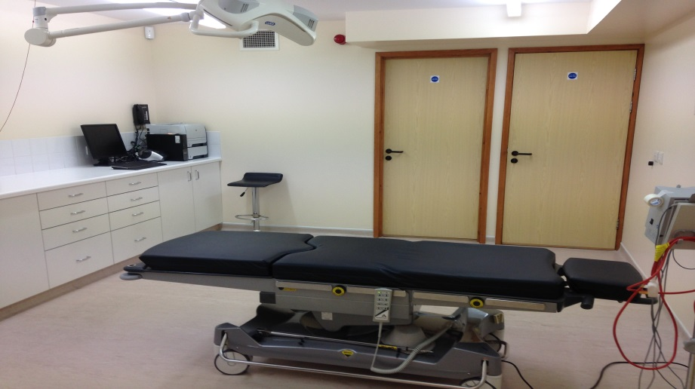
How is it done?
At the clinic we perform the “no-scalpel vasectomy” method under local anaesthetic. The two local injections (similar to the ones used by dentists) are placed just under the skin and around the vas deferens. Your testicles are not injected as some men fear! Once you are numb, a single small opening, measuring less than 1cm, is made in the top of the scrotum using a small cautery device. Through this the doctor can reach the sperm carrying tubes (vas deferens) and seal them using the same cautery instrument. The wound closes naturally and usually no stitches are required. The procedure takes approximately 30 minutes from start to finish.

Does it hurt?
The only painful part of the procedure is the two local anaesthetics which are used. The pain from the injections is usually mild and lasts only a few seconds. Our vasectomy nurse will be with you and her “vocal local” is greatly appreciated by our clients. Most men leave the clinic smiling with relief because the procedure is less painful than they feared. The anaesthetic lasts approximately 3 hours and afterwards there is sometimes a dull ache which can be relieved by taking regular ibuprofen or paracetamol. Some men use a bag of frozen peas wrapped in a towel and applied to the area which can help with the discomfort caused by any swelling or bruising.

What happens after the procedure?
You may feel a bit woozy after the procedure and you will be left to rest for a short while. You will then receive further information about the procedure for collecting your semen tests and will be able to ask the nurse any questions you still have.

How long will I be at the clinic?
The procedure takes about twenty minutes but you will be at the clinic for about 1 hour in total. Your partner is welcome to attend and we recommend that someone accompanies you home. It is illegal for you to drive home after the procedure and not advisable for you to travel by public transport. Reception can order you a taxi if needed.

What are the risks?
Vasectomy is very safe and long-term effects are extremely rare. However, any surgical operation carries a small risk of complications such as pain, bleeding and infection. In the unlikely event that you develop any problems after your vasectomy you can contact our centre during normal working hours (8:30am-6:30pm weekdays) and one of the doctors will advise you over the phone or see you at short notice in our clinic. If you have a problem out of hours you can contact NHS 111.

Infection: Infection is very rare as we usually do not use any stitches, and occurs in less than 1% of cases. Most infections are mild wound infections requiring a short course of antibiotics. The signs of infection are redness, swelling or pus around the wound and you may have a fever.

Bleeding: Most men will get some mild bruising and swelling around the scrotum and base of the penis. This can be minimised by wearing tight underwear and resting as much as possible during the first 48 hours after the operation. A painless lump (pea-sized) may develop in the sperm carrying tube (vas deferens) and persist for a while. This is caused by the body’s natural healing reaction and, again no specific treatment is usually needed. Occasionally there is bleeding from a damaged blood vessel near the van deferens. This causes a collection of blood called a haematoma. This is the most common complication of vasectomy and approximately 1 in a hundred men having the operation will develop a haematoma. This usually occurs within the first 48 hours and hence you should do as little as possible after the operation to minimise the chances of this happening (we advise 48 hours with your feet up on the sofa if possible). In our experience some men develop a haematoma after a week, often having returned to work or normal activities too soon. Remember the wound is tiny and most of the operation took place inside where you can’t see it, so try not to assume that if the wound is healed up you are fully healed on the inside as well. If you think you have developed a haematoma you should let us know. It is painful, but not dangerous and will gradually settle after a few weeks.

Post-vasectomy pain syndrome: A condition called “post vasectomy pain syndrome” has been reported in the medical literature. Unfortunately the evidence of the condition is based upon poor quality studies. It is thought that up to 5% of men (one in twenty) may experience a dull, intermittent aching sensation during the first six months after the vasectomy. This rarely interferes with their normal activities and settles with time and some anti-inflammatory medication. Rarely, these men may require another operation, such as excision of the vas or reversal of the procedure to help this pain. This is extremely rare, occurring in less than 1 in 100,000 cases.

Does vasectomy increase the risk of cancer?
There is no conclusive evidence linking vasectomy and cancer of the prostate of testicles but we advise all men, whether or not they have had a vasectomy, to have regular health screening, including an examination of their testicles.

Is vasectomy reversible?
You should only decide to have a vasectomy as a permanent method of family planning. If you think you might change your mind then you and your partner should consider an alternative method of contraception and wait until you are 100% sure of your decision. Approximately 1% of men who have a vasectomy are said to regret their decision at some stage, usually because of unforeseen changes to their family circumstances.

Will vasectomy affect my sex life?
Many couples find greater sexual freedom once the risk of unwanted pregnancy has been removed. Erection, orgasm and ejaculation are not affected. Sperm continue to be produced by the testicles but their passage to the penis is blocked and they are re-absorbed by the body. Vasectomy has no effect on the production of male hormones.

You can have sex again as soon as you feel comfortable. We recommend that you wait a few days to give the incision time to heal. You will need to use another method of contraception until we write to tell you that your vasectomy has been effective based on the result of your sperm test. Please do not be alarmed if you see blood in the semen on the first few times you ejaculate, this is quite normal.

Post- operative advice
Washing: You can have a shower or brief bath after 48 hours. You should wash and dry the area gently to avoid disturbing the wound.

Clothing: We suggest you wear tight fitting pants or jockstrap day and night for a week after your operation. This supports the testes and reduces the risk of small vessels bleeding and therefore reduces the likelihood of severe bruising and swelling.

Ice packs: For the next 2 days apply an ice pack to the area up to four times a day for 10-15 minutes. This can reduce the likelihood of swelling and bruising as it shrinks the small blood vessels which may have been damaged.

Sports: You should avoid all sport for the first week and should avoid strenuous sports for at least 2 weeks, contact sport such as rugby for at least 3 weeks and strenuous cycling for at least 4 weeks. Walking and gentle swimming etc can be resumed as soon as it feels comfortable. If you need advice on a particular sporting activity please speak to the nurse.

Will I need to take time off work?
You will need to take the next day off work and take things easy for the next couple of days. If you have a physically demanding job you may need to take up to a week’s leave from work and if you do return to work you should avoid all strenuous work for at least two weeks. Post-operative discomfort level vary enormously so you must proceed thereafter as you think fit.

How do I know if the vasectomy has worked?
We will ask you to supply a semen specimen 18 weeks after your vasectomy and you will be given a sample container to take away with you for this purpose. Your sample is checked under a microscope to see if sperm are present. If there are no sperm in your sample we will send you an “all clear” letter. You can then have sex without using another method of contraception. It can take quite a number of ejaculations to clear the tubes of sperm, so we may need to ask you for more samples. We will keep you updated on what is happening and why at all stages.

Please see the instructions on processing and postage of post-vasectomy semen specimens attached.

We ask that you read and ensure you understand all the information in this pack prior to booking your vasectomy. After you have discussed your vasectomy with Dr Mandal we will ask you to sign the consent form at the back of this pack.

If you are unsure whether vasectomy is the right choice for you please feel free to call Dr Mandal to discuss your concerns. Lorna on the number above will arrange for Dr Mandal to call you back.

Remember before the operation

- Wear tight, supportive underwear
- Buy some paracetamol and ibuprofen (Nurofen)
- Arrange for someone to drive you home

INSTRUCTIONS ON PROCESSING AND POSTAGE OF POST-VASECTOMY SEMEN SPECIMENS

- Produce specimen on Monday or Tuesday in the specimen pot provided no earlier than 18 weeks after your vasectomy.
- You should produce a minimum of 24 ejaculations before producing your sample for testing.
- You should abstain from ejaculating for 48 hours prior to producing your sample.
- Please ensure the whole ejaculate is collected in the sample pot provided.
- Write the date and time of the specimen on the pot and ensure it has your name on it. Wrap the pot in the soft wadding provided and seal in the plastic bag
- Write the date and time of the specimen on the Patient’s details slip, roll up slip and place in the envelope.
- Place in a post box for collection on the same day as you have produced the sample.
- It is important that the specimen is produced on the same date as is written on the form and pot, and posted the same day
- You will be informed by post of the results

Please produce and send semen sample on or after:

Date: ______________________

BOROUGH GREEN MEDICAL PRACTICE VASECTOMY SERVICE

CONSENT FORM

I confirm that I have read and understood the contents of this information pack and that I wish to have a vasectomy.

Print Name _______________________________

Signed ___________________________________

Dated ____________________________________

VASECTOMY PRE-OP ASSESSMENT

PLEASE BRING TO SURGERY ON DAY OF VASECTOMY

Name of Patient ………………………………………………………………………………..

Date of Birth ……………………………………………………………………………………………..

Address ………………………………………………………………………………………………………….

……………………………………………………………………………………………………………………….

Contact Telephone Nos......................................................................................

Length of Marriage (or co-habitation)……………………………………………………………..

No of Children (including any from previous relationships)...……………………………

Ages of Children………………………………………………………………………………………………

Medical History

Medical Conditions…………………………………………………………………. (past or current)

Any bleeding disorders in Family (e.g. haemophilia, Factor V deficiency etc.)

………………………………………………………………………………..........................................

Operations on scrotum or abdomen ………………………………………………………………….

Trauma to Testes……………………………………………………………………………………………….

Medications – are you currently taking any of the following? (mark yes or no)

Warfarin Yes No If you answer yes to any of
these questions will you
Aspirin Yes No kindly contact Dr Mandal
two weeks prior to your
Clopidogrel Yes No vasectomy

Tigracelor Yes No

Rivaroxaban/ Apixaban Yes No

Fragmin/Dalteparin Yes No

Allergies (give further details)

